**Proposal- James Bond Film Facts**

**Francesco Gisonni**

**Background Information**

After much decision making and self debating, I finally decided on a infographic I feel strongly confident in working on. Knowing James Bond is releasing a brand new film I thought, ‘why not make a infograph on the films?’ So the name of my infograph is James Bond Film Facts. The information this inforgraph will provide will be on how much each movie made, how much the budget was, and how much revenue each movie made during its time in the box office. Along with the movie revenues there will be fun facts such as, overall rating, release year, the actor who played James Bond, the villain, and the country(ies) the movie was filmed in.

**Purpose and Objectives**

I want people to see this information to see which James Bond movie was most successful. Drawing a bigger crowd to the James Bond series to know how successful each movie was. Also, James Bond began in 1963, so new fans who want to get involved with the series can view the chart and look at which movie, based on the stats, is worth watching.

**Target Audience**

The audience interacting with this infograph are, serious James Bond fans, new James Bond fans, movie lovers, and critics who enjoy knowing box office sales. There’s a lot of websites out there based on movies, but this interactive infograph will only be based on James Bond.

**References**

When looking for references I wanted to keep my search simple in looking for sites with strictly infographs so that I know everything I will be referencing will be influenced by the assignment topic. Here are the infographs I found:

**Reference One:**

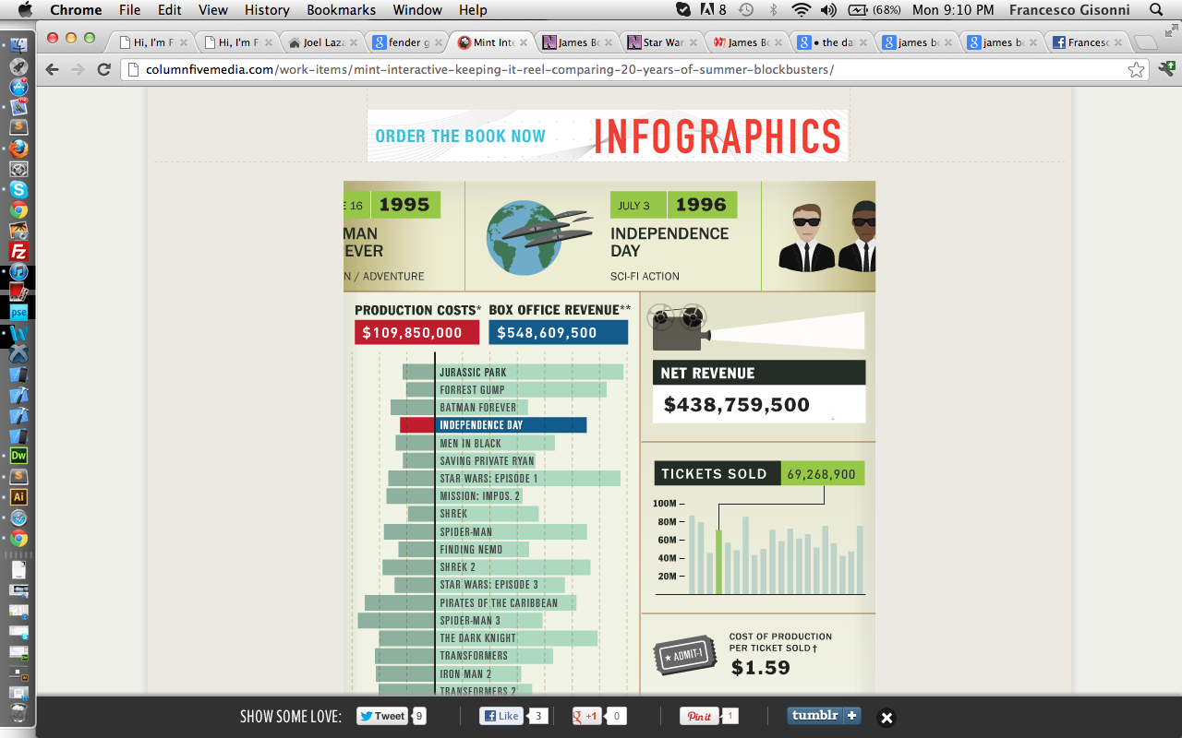

<http://columnfivemedia.com/work-items/mint-interactive-keeping-it-reel-comparing-20-years-of-summer-blockbusters/>

The main inspiration was actually based off of this example. I wanted to do something based of income, and other interesting facts, and this infograph gave me the take off I needed. It was straight the point and very simple. The only thing was that it was almost too simple I felt. I like the way how it distributes the information, but I was there was a little more interactivity. The overall design is awesome. I like how they gave all the movies a very cartoony feel to them.

**Reference Two:**

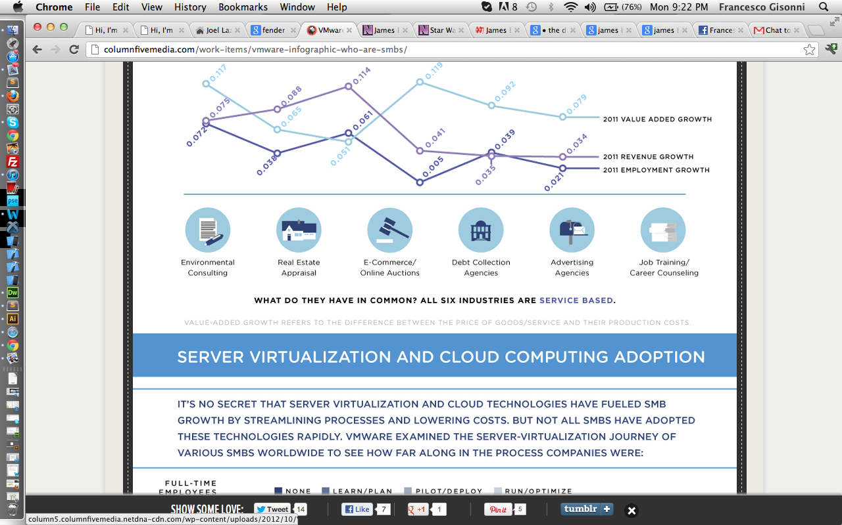

<http://columnfivemedia.com/work-items/vmware-infographic-who-are-smbs/>

This infograph includes charts which is something I want to include within my infograph. The one in the screen shot above is something I really want use as a chart somewhere in my infograph! It seems pretty cool and very easy to make interactive and quite interesting. The circle icons are another thing that really caught my attention as well. Which makes it pretty cool to reference. The only down fall is that it’s just a still image so it inspires me to make something similar interactive.

**Reference 3:**

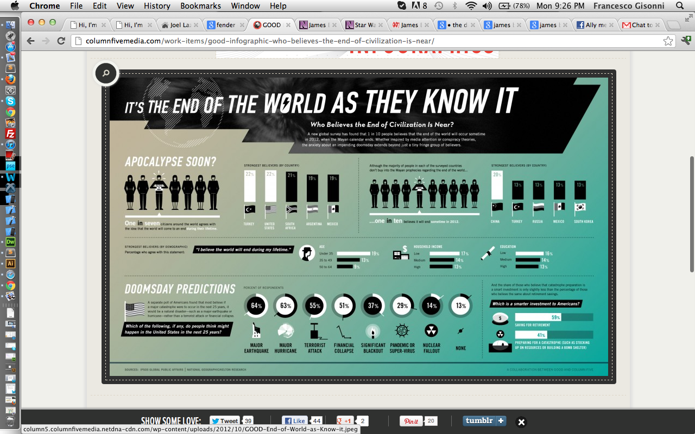

<http://columnfivemedia.com/work-items/good-infographic-who-believes-the-end-of-civilization-is-near/>

I plan on using little characters for my infograph. Even this whole design on its own just really captures what I kind of want to do. The wicked title going on at the top just makes it feel like a super agent is coming after you. The gradient is something I don’t want to go after. James Bond is a solid character who deserves a solid colour.

**Data:**

Box Office, Name of Movie:

<http://www.the-numbers.com/movies/series/JamesBond.php>

Countries

<http://www.mi6-hq.com/sections/locations/index.php3>

Ratings:

<http://www.imdb.com/list/mkrZEfz3ngo/>

http://www.rottentomatoes.com/

Villains:

<http://www.jamesbondvillains.com/James-Bond-Villains/James-Bond-Villains.html>

James Bond Actor, Gross Pay (optional):

<http://www.007james.com/articles/box_office.php>

**Year of Release, Countries Per Movie, Actor, Rating & Villain:**

|  |  |  |  |  |
| --- | --- | --- | --- | --- |
| **Movie** | **Countries** | **Actor** | **Rating** | **Villain** |
| Dr. No – 1963 | Jamaica  UK | Sean Connery | 98% | Dr. Julius No |
| From Russia With Love - 1964 | Italy  Turkey  UK  Yugoslavia | Sean Connery | 96% | Rosa Klebb, Blofeld |
| Gold Finger - 1964 | Switzerland  UK  USA | Sean Connery | 96% | Auric Goldfinger, OddJob |
| Thunder Ball –  1965 | Bahamas  France  UK  USA | Sean Connery | 85% | Emilio Largo, Blofeld |
| You Only Live Twice –  1967 | Hong Kong  Japan  UK  USA | Sean Connery | 70% | Ernst Stavro Blofeld |
| On Her Majesty’s Secret Service - 1969 | Portugal  Switzerland  UK | George Lazenby | 81% | Ernst Stavro Blofeld |
| Diamonds Are Forever - 1971 | Egypt  Mexico  Netherlands  UK  USA | Sean Connery | 64% | Blofeld, Mr. Wint, Mr. Kidd |
| Live and Let Die - 1973 | Bahamas  UK  USA | Roger Moore | 65% | Mr. Big |
| The Man with the Golden Gun - 1974 | Hong Kong  Thailand  UK | Roger Moore | 46% | Francisco Scaramanga |
| The Spy Who Love Me - 1977 | Austria  Egypt  Italy  UK | Roger Moore | 78% | Karl Strombreg, Jaws |
| Moonraker - 1979 | Brasil  France  Italy  UK  USA | Roger Moore | 62% | Hugo Drax, Jaws |
| For Your Eyes Only - 1981 | Albania  Greece  Italy  Spain  UK | Roger Moore | 73% | Aristotle Kristatos |
| Octopussy –  1983 | Germany  India  UK | Roger Moore | 43% | Kamal Kahn |
| Never Say Never Again –  1983 | Bahamas  France  Monaco  UK  USA | Sean Connery | 61% | Fatima Blush, Largo |
| A View to Kill  - 1985 | France  Russia  UK  USA | Roger Moore | 36% | Max Zorin |
| The Living Daylights - 1987 | Afghanistan  Austria  Czech Republic  Gibraltar  Morocco  UK | Timothy Dalton | 75% | General Georgi Koskov |
| License to Kill - 1989 | UK  USA | Timothy Dalton | 74% | Frank Sanchez |
| Goldeneye –  1995 | Cuba  Monaco  Russia  UK | Pierce Brosnan | 82% | Alexander “Alec” Trevelyan |
| Tomorrow Never Dies -  1997 | China  Germany  Pakistan  UK  Vietnam | Pierce Brosnan | 57% | Elliot Carver |
| The World is Not Enough –  1999 | Azerbijan  Kazakhstan  Spain  Turkey  UK | Pierce Brosnan | 51% | Elektra  King |
| Die Another Day –  2002 | Cuba  Hong Kong  Iceland  North Korea  UK | Pierce Brosnan | 57% | Gustav Graves,  Zao |
| Casino Royale  - 2006 | Bahamas  Czech Republic  Italy  Madagascar  Montenegro  Pakistan  Uganda  UK  USA | Daniel Craig | 95% | Le Chiffre |
| Quantum of Solace - 2008 | Austria  Bolivia  Haiti  Italy  Russia  UK | Daniel Craig | 64% | Dominic Greene |

**­**

**Box Office:**

|  |  |  |  |  |
| --- | --- | --- | --- | --- |
| **Movie** | **US Gross($)** | **Worldwide Gross($)** | **Budget($)** | **Net Revenue**  **(minus Worldwide Gross)** |
| Dr. No | 16, 067, 035 | 59, 567, 035 | 1, 000, 000 | 58, 567, 035 |
| From Russia With Love | 24, 800, 000 | 78, 900, 000 | 2, 000, 000 | 76, 900, 000 |
| Goldfinger | 51, 100, 000 | 124, 900, 000 | 3, 000, 000 | 121, 900, 000 |
| Thunderball | 63, 600, 000 | 141, 200, 000 | 9, 000, 000 | 132, 200, 000 |
| You Only Live Twice | 43, 100, 000 | 111, 600, 000 | 9,5000, 000 | 102, 100, 000 |
| On Her Majesty’s Secret Service | 22, 800, 000 | 82, 000, 000 | 8, 000, 000 | 74, 000, 000 |
| Diamonds Are Forever | 43, 800, 000 | 116, 000, 000 | 7, 200, 000 | 108, 800, 000 |
| Live and Let Die | 35, 400, 000 | 161, 800, 000 | 7, 000, 000 | 154, 800, 000 |
| The Man with The Golden Gun | 21, 000, 000 | 97, 600, 000 | 7, 000, 000 | 90, 600, 000 |
| The Spy Who Loved Me | 46, 800, 000 | 185, 400, 000 | 14, 000, 000 | 141, 400, 000 |
| Moonraker | 70, 300, 000 | 210, 300, 000 | 31, 000, 000 | 179, 300, 000 |
| For Your Eyes Only | 54, 800, 000 | 195, 300, 000 | 28, 000, 000 | 167, 300, 000 |
| Octopussy | 67, 900, 000 | 187, 500, 000 | 27, 500, 000 | 160, 000, 000 |
| Never Say Never Again | 55, 500, 000 | 160, 000, 000 | 36, 000, 000 | 124, 000, 000 |
| A View to Kill | 50, 327, 960 | 152, 627, 960 | 30, 000, 000 | 122, 627, 960 |
| The Living Daylights | 51, 185, 000 | 191, 200, 000 | 40, 000, 000 | 151, 200, 000 |
| License to Kill | 34, 667, 015 | 156, 167, 015 | 42, 000, 000 | 114, 000, 000 |
| Goldeneye | 106, 429, 941 | 356, 429, 941 | 60, 000, 000 | 296, 429, 941 |
| Tomorrow Never Dies | 125, 304, 660 | 339, 504, 276 | 110, 000, 000 | 229, 504, 276 |
| The World is Not Enough | 126, 930, 660 | 361, 730, 660 | 135, 000, 000 | 226, 730, 660 |
| Die another Day | 160, 942, 139 | 431, 942, 139 | 142, 000, 000 | 289, 942, 139 |
| Casino Royale | 167, 365, 000 | 596, 365, 000 | 102, 000, 000 | 494, 365, 000 |
| Quantum of Solace | 169, 368, 427 | 591, 692, 078 | 230, 000, 000 | 361, 692, 078 |